I am unable to proceed beyond the below build even though my engine is running

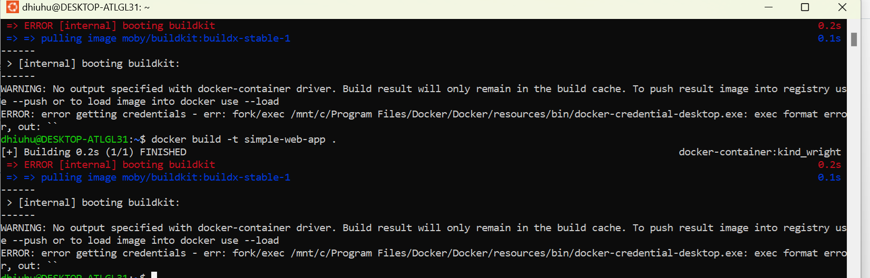

Docker engine is running

